1-What is service Registry?

Ans:- A service registry used in microservices architecture to enables dynamic service discovery.

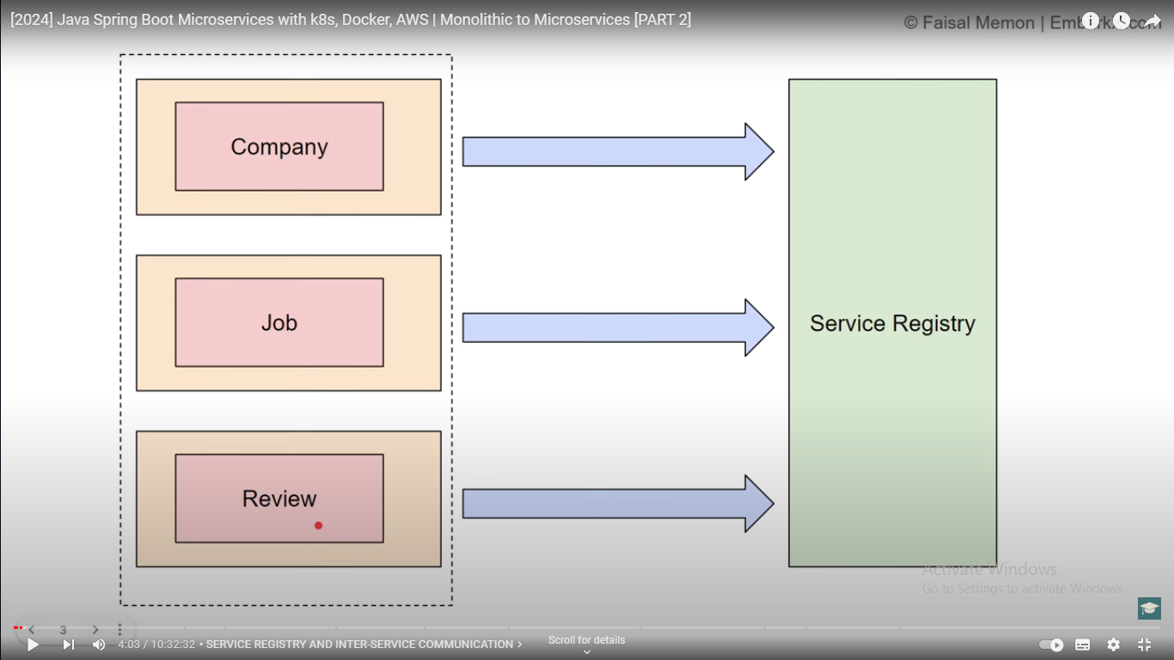

Project: structure:-  
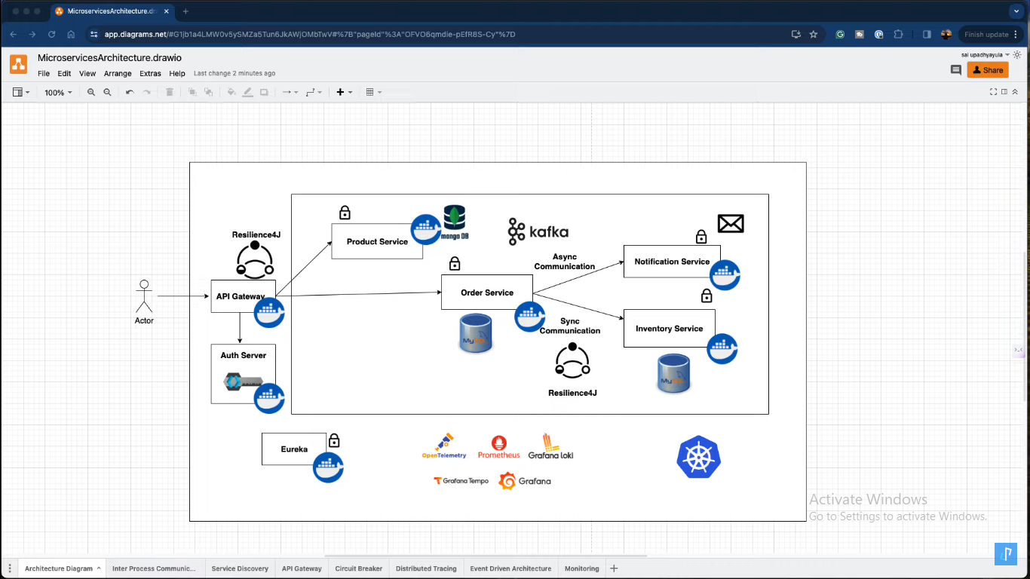

Synchronous communication diagram:-

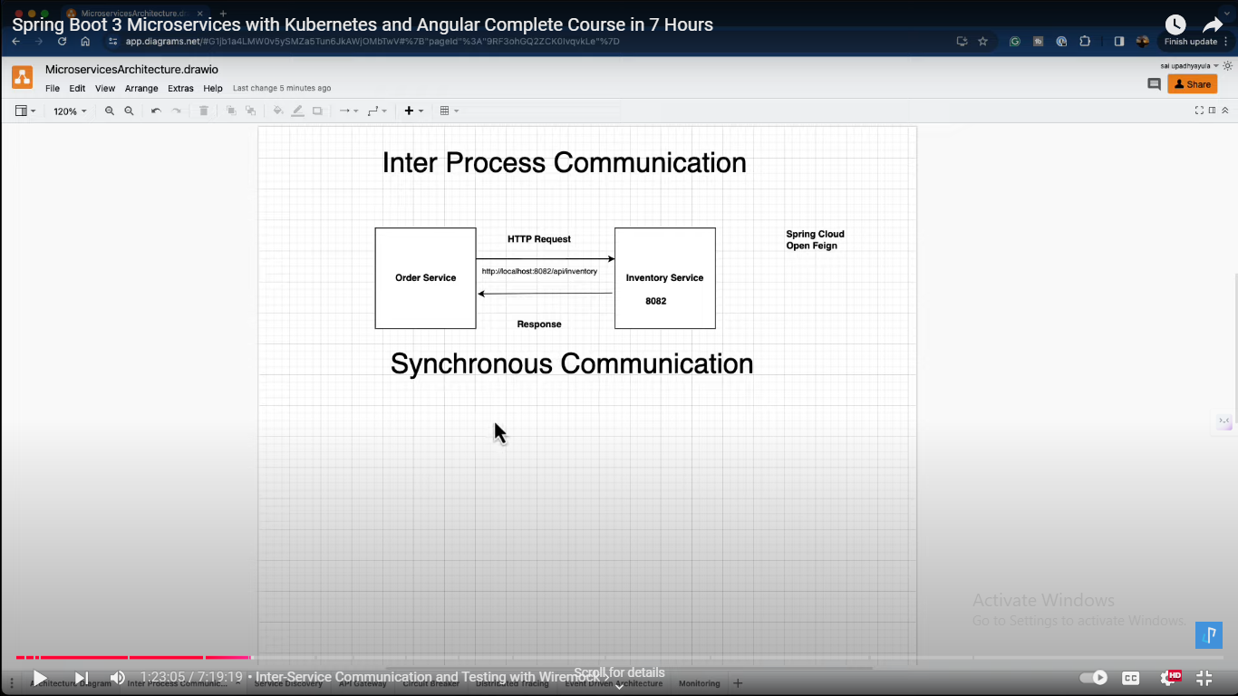

1. Mokito:- Use mock to mock the API for unnecessary used.
2. Wiremock:-

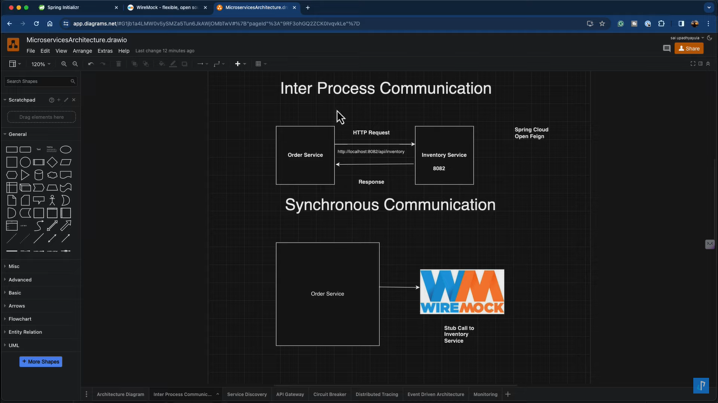

**Lession 5**

**API Gateway**

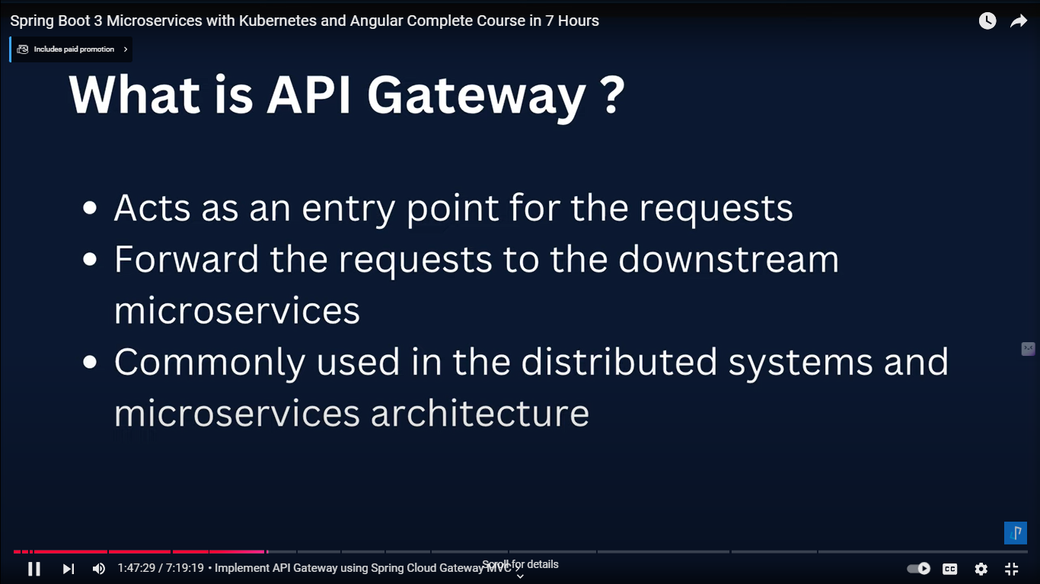

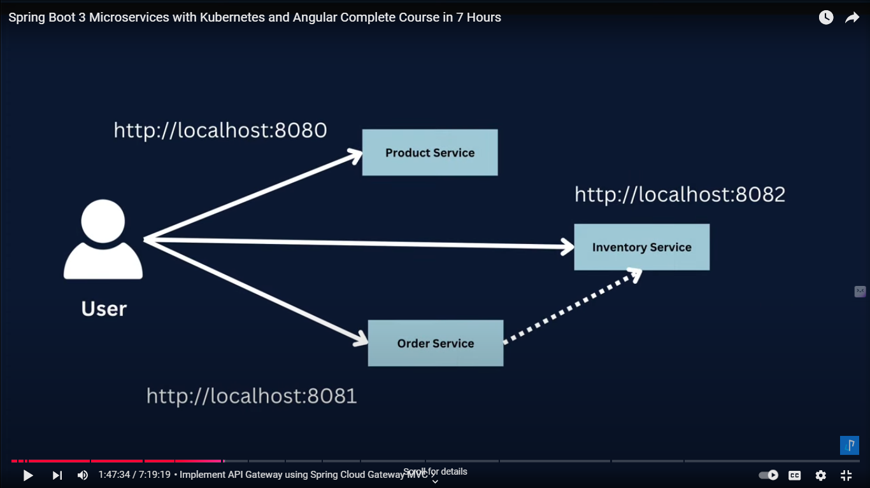

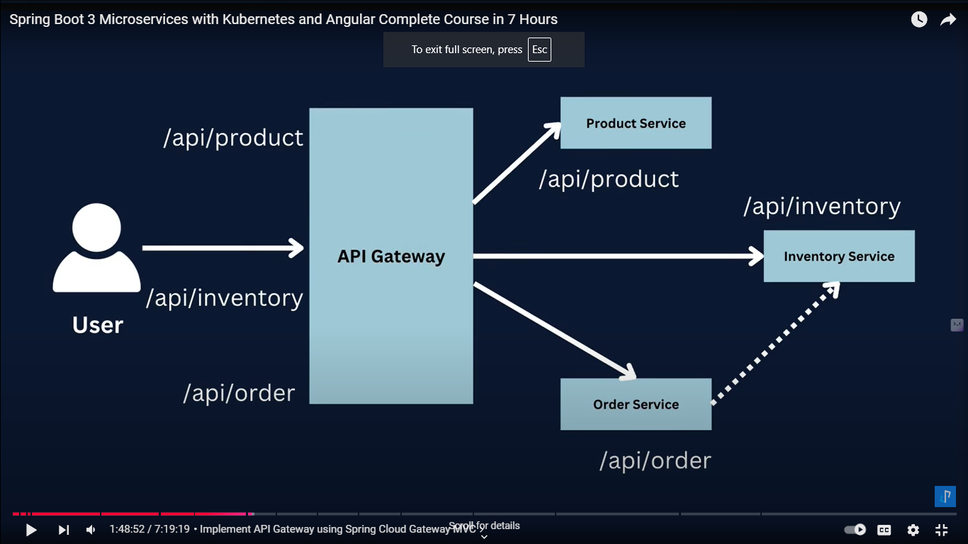

Benefits os Ms:-

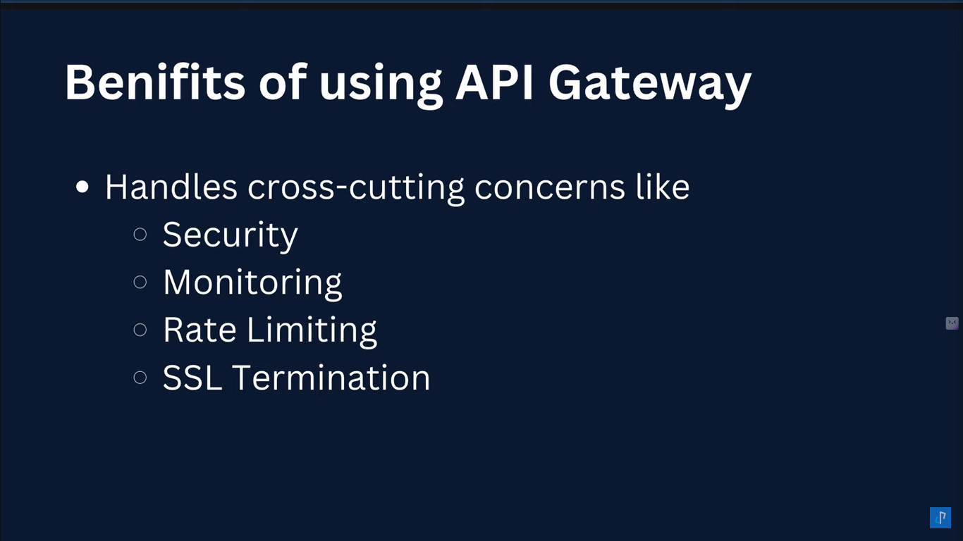

Disadvantages of

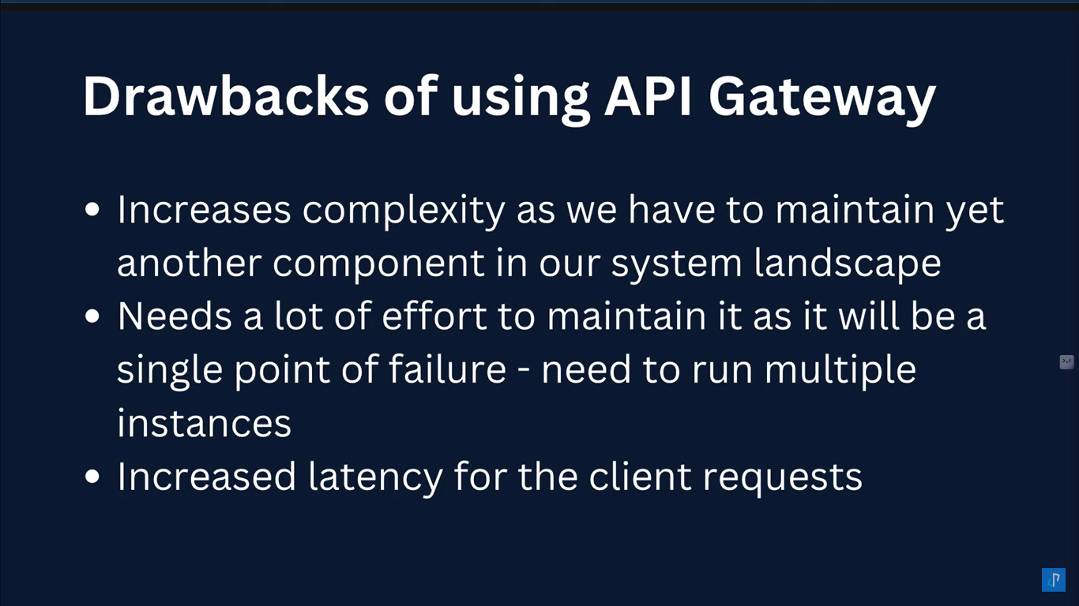

**Keycloak for Authentication ms**

<https://www.keycloak.org/>

D:\2024\keyclock-oauth2\keycloak-26.0.5\keycloak-26.0.5\bin>kc.bat start-dev

Default port and URI below from logs:  
<http://127.0.0.1:8080/>

Create user

t1137ravi

Pass

[T1137ravi@gmail.com](mailto:T1137ravi@gmail.com)

Lession 5: Make API documentations using swagger & OPenAPI

------------------------------------------------------------------------------------------------------------------------------------------

<https://www.openapis.org/>

<https://swagger.io/specification/>

<https://springdoc.org/> // open API and springdocs

<dependency>

<groupId>org.springdoc</groupId>

<artifactId>springdoc-openapi-starter-webmvc-ui</artifactId>

<version>2.6.0</version>

</dependency>  
  
Below is the Sample Url

http://localhost:8080/swagger-ui/index.html

http://localhost:8080/api-docs

---------------------------------------------------------------------------------------------------------------------------------------

Circuit breacker Using Resilience4j  
---------------------------------------------------------------------------------------------------------------------------------------

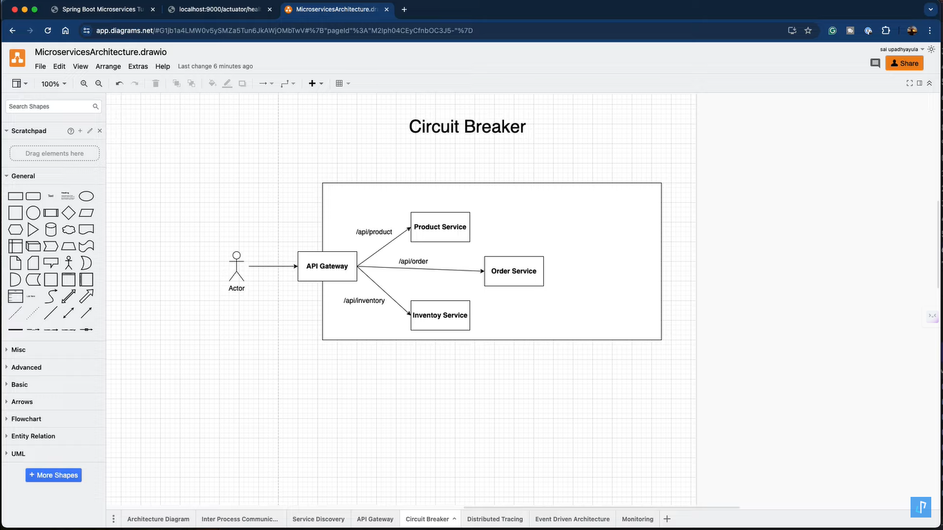

Lession Angular: Part taken from repo

**Lesson : Event Driven Architecture Using Kafka Tracing**

[**https://kafka.apache.org/**](https://kafka.apache.org/)

